Pledge Card Design 2

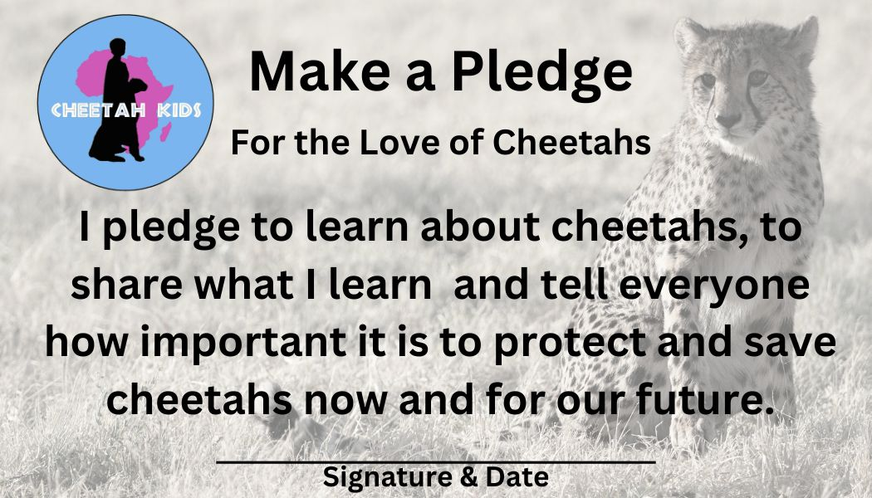

For the Love of Cheetahs Pledge Card Activity

A pledge is defined as a promise or an agreement. To make a pledge to help save cheetahs is very important because cheetahs, like all wildlife need people to speak up for them. The more people learn about cheetahs the better chance they have to thrive and survive into the future.

So let's make a difference together! Let’s make a pledge to learn about cheetahs, to share what you learn and tell everyone how important it is to protect and save cheetahs now and for our future!

Instructions:

1) Print this pledge card (color or black and white)

Suggestion: Print it on cardstock (heavier piece of paper) so that it lasts longer.
If needed, you can always ask your parents to help you with the printing and cardstock.

2) Cut out the pledge card

3) Read it out loud to at least one person to make your pledge official.

4) Sign and date it.

5) Now go out and fulfill your pledge. Share what you learn and tell everyone how important it
is to protect and save cheetahs now and for our future!

Suggestion: Discover Cheetah Kids’ crafts and activities that can help you fulfill your pledge.

Thank you for taking the pledge with us!

